Assignment 2 – Eating out Habits and Health Awareness
Survey Screen shots:
https://docs.google.com/forms/d/e/1FAIpQLScL-GxN5wUt-YsyCfkrEy2ToKA0xcBOBrlY959WXHD_F0GCfQ/viewform

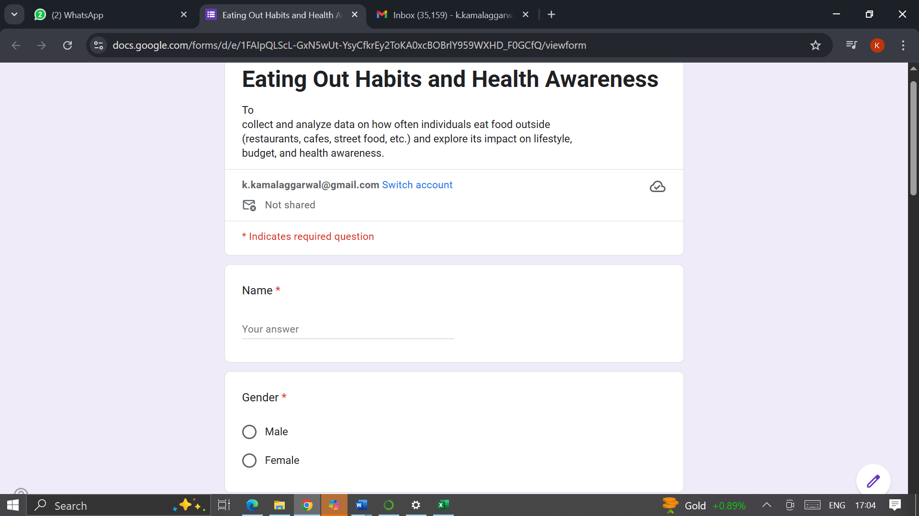
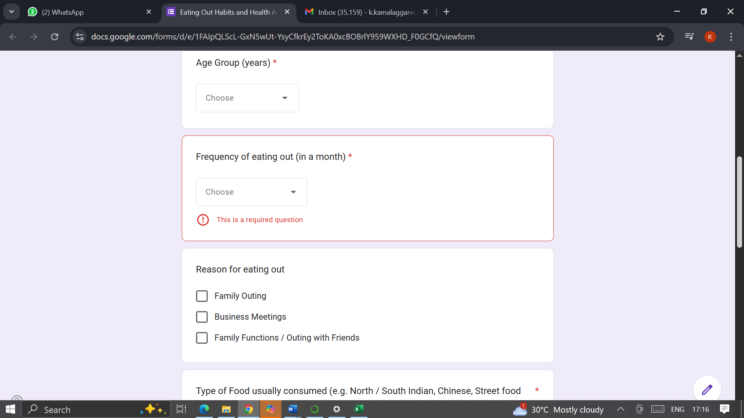

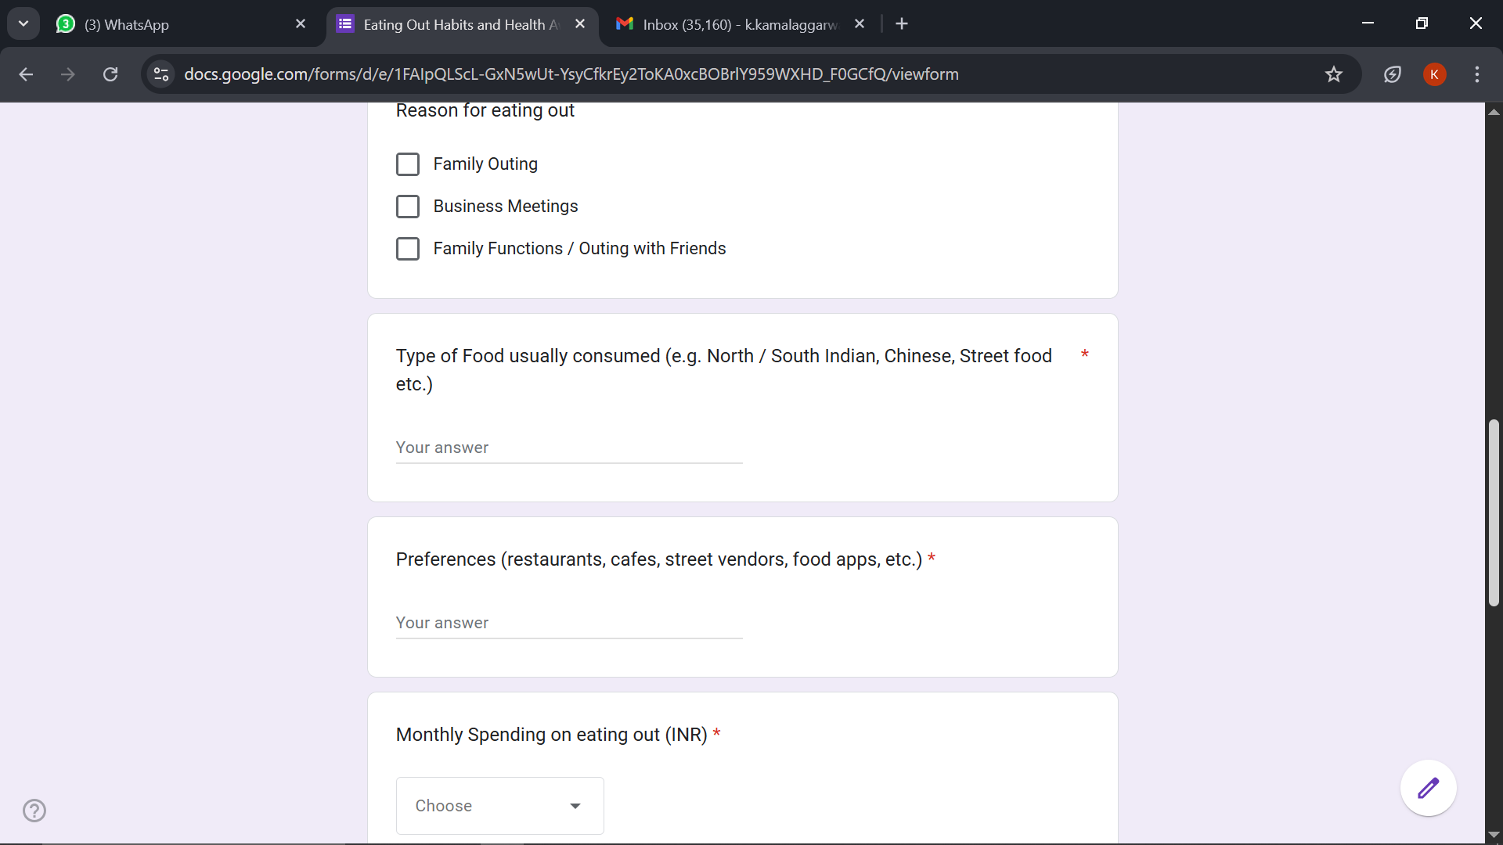

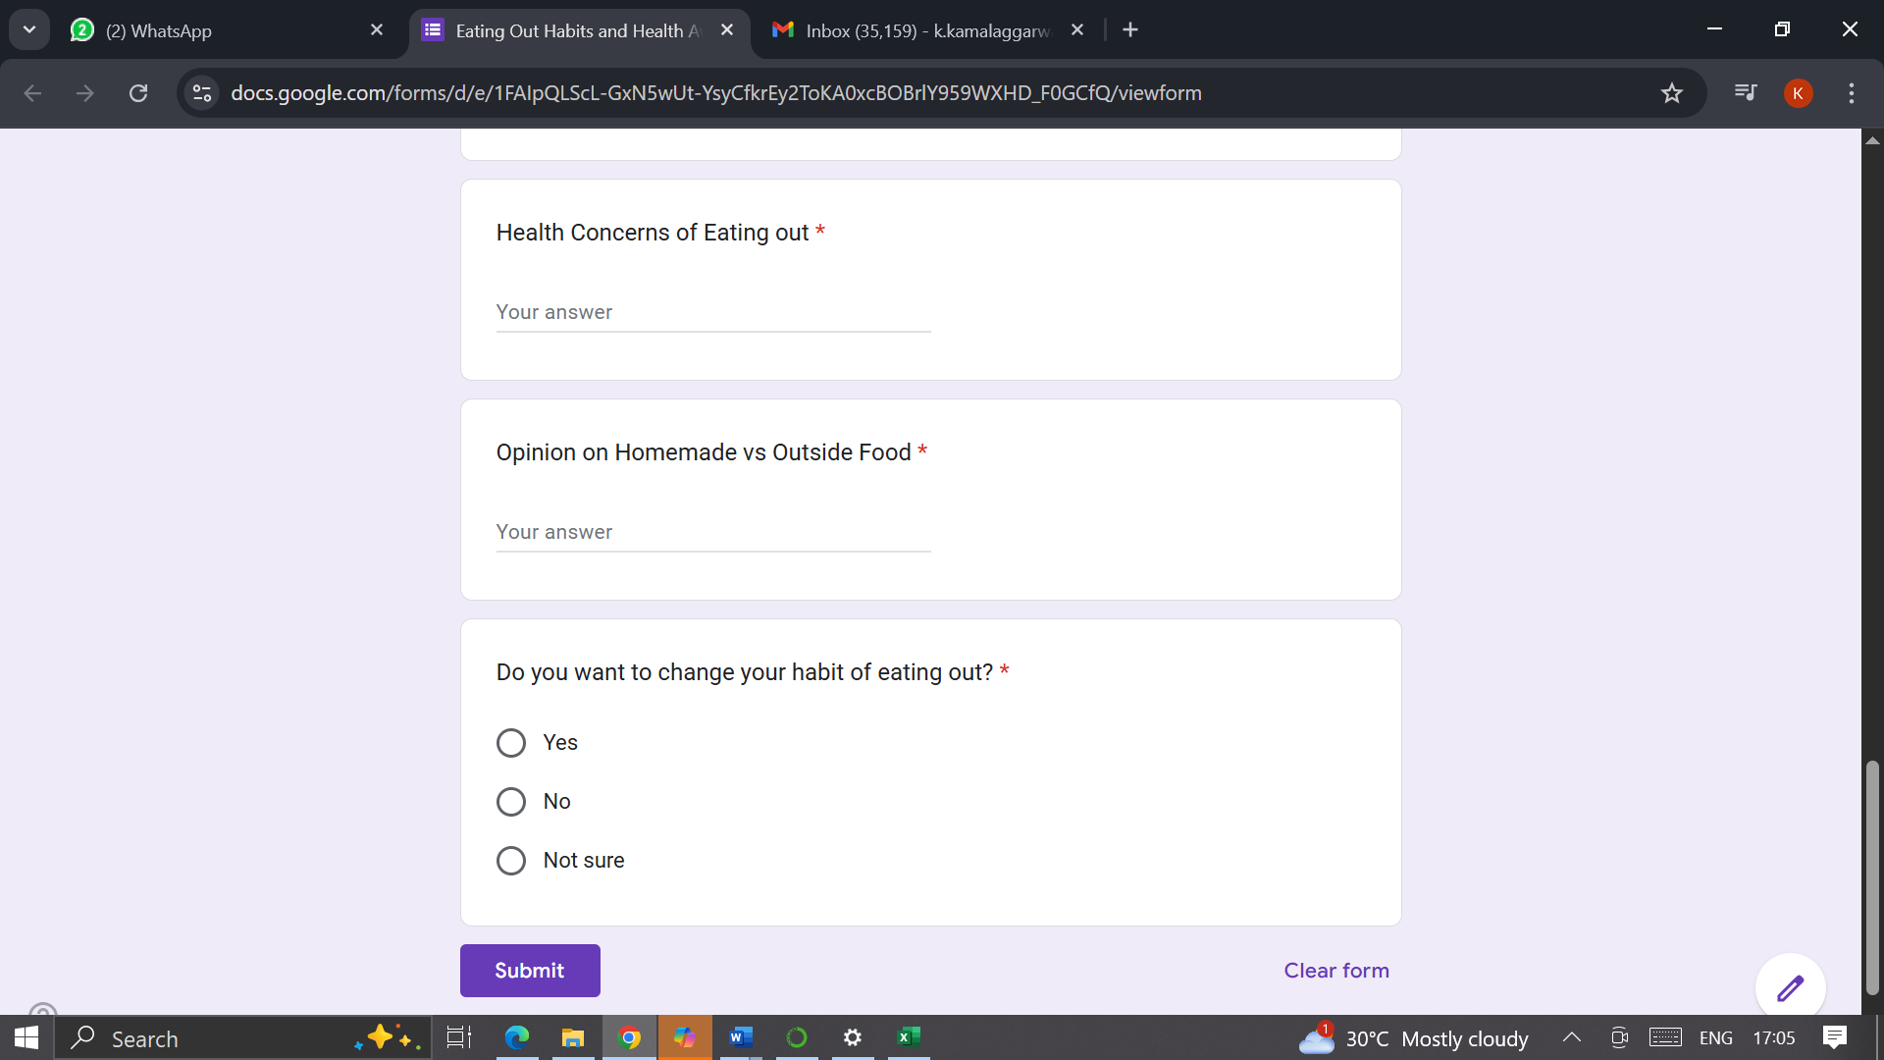

Key Findings:
- No Data received for Age Group 19 – 30.
- Maximum respondents belonged to Age Group 31 – 50
Analysis:
- Based on the given data, people eat out 4-7 times in a month on an average
- Based on the responses, people like North Indian food more
- Even-though people are eating out but they are not concerned about effects on health. Only 8 (40%) have mentioned that they are concerned about health.
- Average spending per person on eating out is INR 2300
- People with age group 31 – 50 are eating out more frequently 8-11 times a month
Observations: Based on analysis of response data:
- People from age group 31-50 are eating out more frequently and spending good amount of money.
- Even-though there are health concerns of eating out, people are still liking to eat out.

Suggestions to encourage healthy food habits:
- Include healthy items in homemade food
- For different taste buds, try different cuisines and dishes at home

